|  |  |  |  |
| --- | --- | --- | --- |
| **CS102** | **Spring 2016/2017** | Project Group | 1A |
| Instructor: | **Instructors Name** |  |  |
| Assistant: | Assistant's Name |  |  |

|  |  |  |
| --- | --- | --- |
| **Criteria** | **TA/Grader** | **Instructor** |
| Presentation |  |  |
|  |  |  |
|  |  |  |
|  |  |  |
| Overall |  |  |

~ Project Title ~

group_name

Author Names

|  |
| --- |
| Report Type  ( report subtype/version )  9 November 2017 |

# Introduction

We are going to create a single player tower defense game which will be different from the classical tower defense type. It is going to be a desktop game, written in java. The user will be allowed to build his towers anywhere he wants on the map. In this way, he will create his own maze that requires advanced strategies than the classical types require. The game will be challenging because of its AI that can change its strategy in different situations. As far as possible, do not change any of the formatting, but rather use the existing styles.

We want to design UI which is easy to understand by a player. Player must use keyboard and mouse together to play game. In order to make an action player can use keyboard shortcuts to accelerate his gameplay. Generally player uses mouse to control game.

# Details

Main menu of the game is simple as in the below figure which contains Play Game, Load Game, Scoreboard, Setting, Exit, Music Off, Sound Off buttons. When the player presses Exit button, player quits the game.

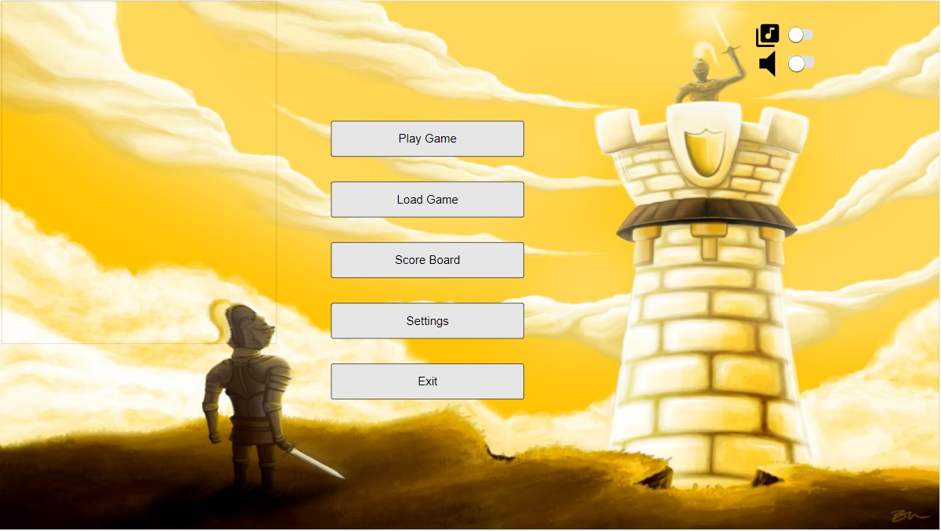

When the player presses Load Game button, player can choose his old save games to continue his old game.

When the player presses Scoreboard button, he will see his records for each difficulty mode separately as in the below figure (if it exists.)

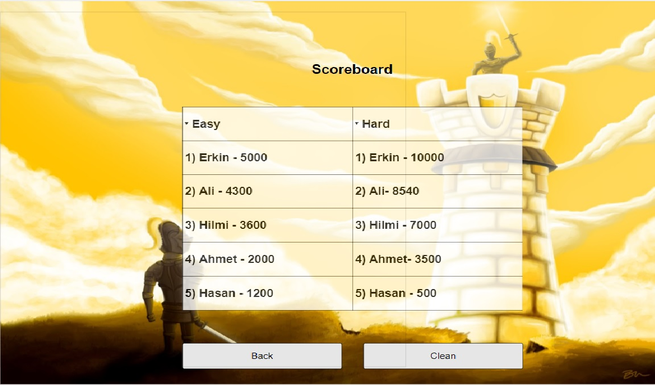

When the player presses Setting button, he will see the control panel which he can change keyboard shortcuts of the game and also enable several options for the game e.g instructions for the game as in the below figure.

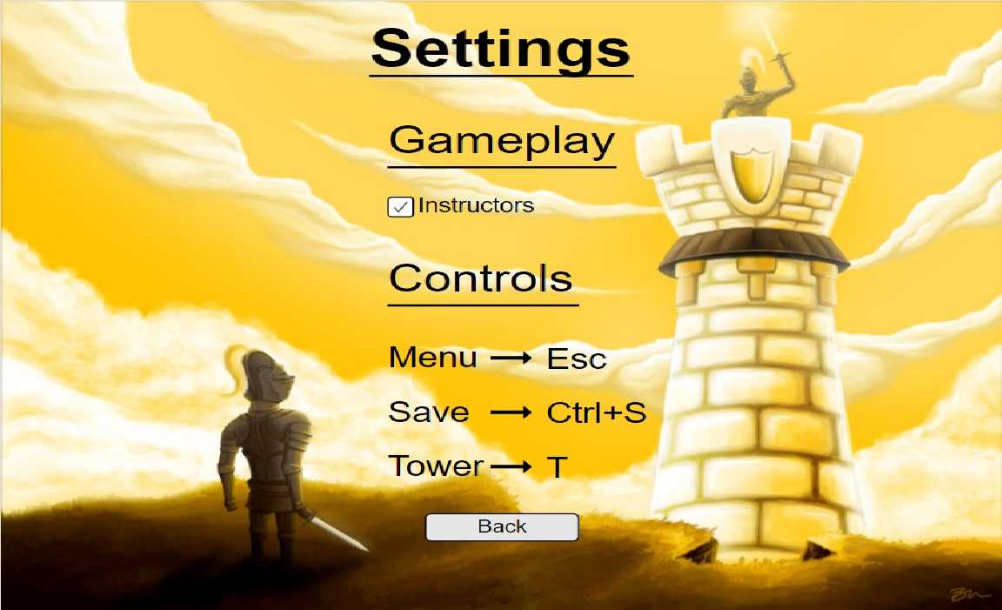

When the player presses Music Off or Sound Off buttons, music or sound is disabled until player enables it.

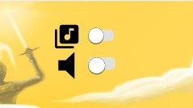

When the player presses Play Game button, it will be asked to set difficulty of the game as in the below figure.

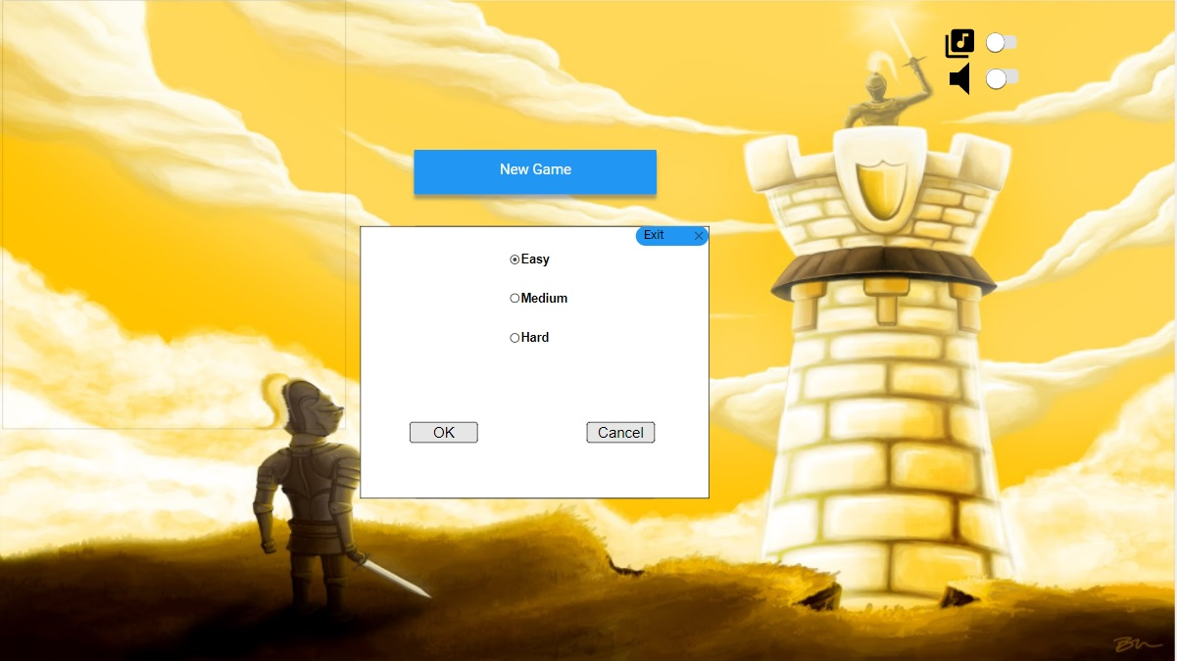

After the player set the difficulty of the game, game will be getting started. After a moment, game starts with random path as in the below figure. (White boxes which contains explanation will not be displayed in the game, it is just for clarification for this report.)

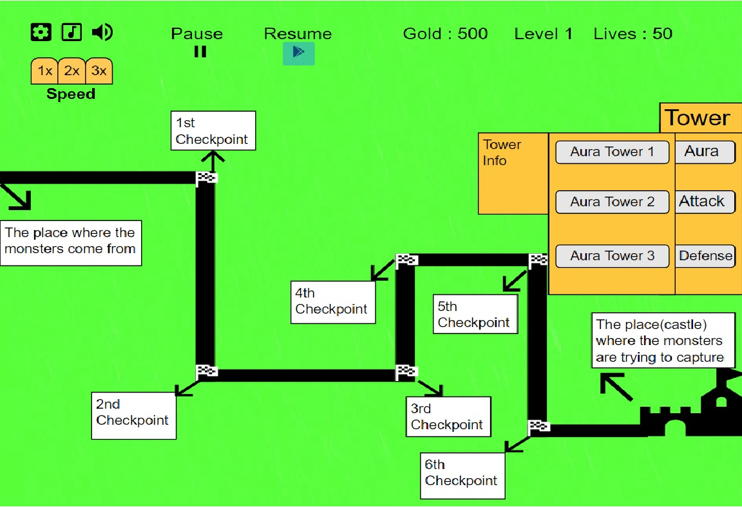

When the player presses Settings button (which is “Gear” on the left top) or Pause button, game is paused and pause menu will appear as in the below figure.

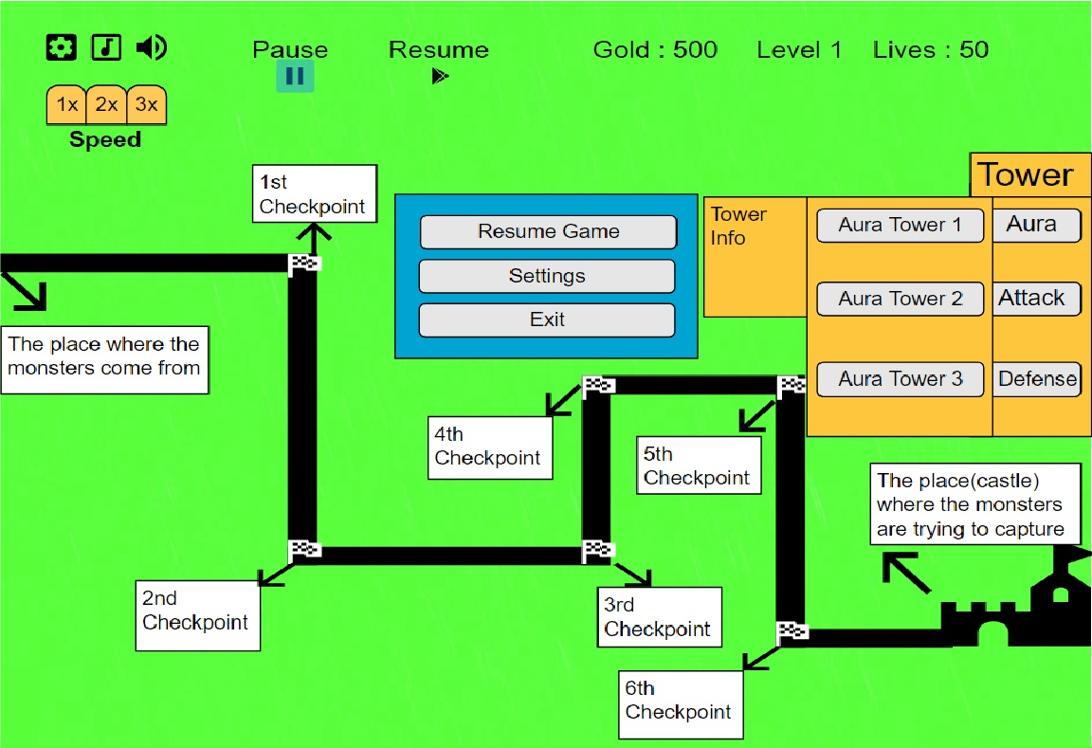

In order to explain our Game Hud, we have a figure which does not contains path to focus other parts for the report. In the game, there will be a tab which can player choose any tower type to strategize his maze against monster. When he presses any kind of tower (Aura, Attack, Defense) another tab will appear which contains several towers with different features of that chosen type. If the player moves the cursor on his selection (tower), Tower Info will appear to inform the player about the features of that tower. On the other hand, on the screen there will be information about Gold, Level and Lives. Gold is simply economy of the player so that player can build new towers or upgrade his own towers or skills. Level indicates the progress of the player in the game, higher levels will be more challenging. Lives is the following, if the player runs out of his lives in the games, he is defeated. (In the game he can also gain Lives if the player achieves some tasks. The player uses Pause button to pause game and resume the game by the Resume Button at his pleasure. Music and Sound buttons simply disable or enable the music and sound. Lastly, there will be an option to choose the speed of the game to speed up the game so that experienced players (who can foresee levels) can play the game faster. (as in the below figure)

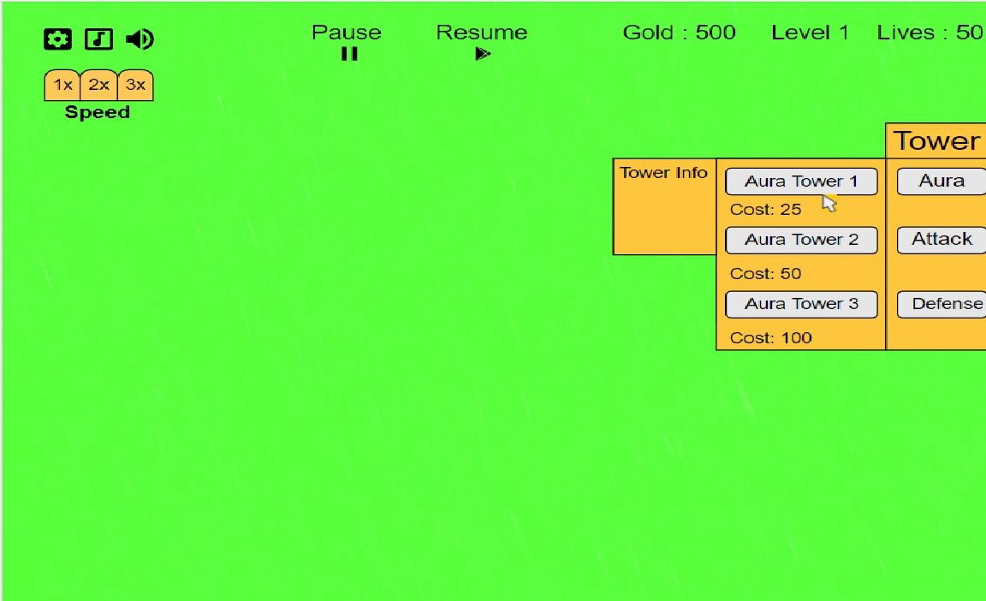

In order to explain our Maze System, we have a figure which contains only maze to focus our Maze System for the report. In the game, there will be a random path which monsters follow that path and the player will construct his maze in order to give monsters a hard time. In the path, there will be several checkpoints which monsters should reach that checkpoints in order to progress their duty. For that reason, if the player creates a maze around that checkpoints, monsters will travel more. Therefore, monsters should have pathfinding ability in order to reach each checkpoints and finally castle to decrease Lives of the player. In order to have good pathfinder monsters we use search algorithms. (i.e Dijkstra Algorithm or A* Algorithm)

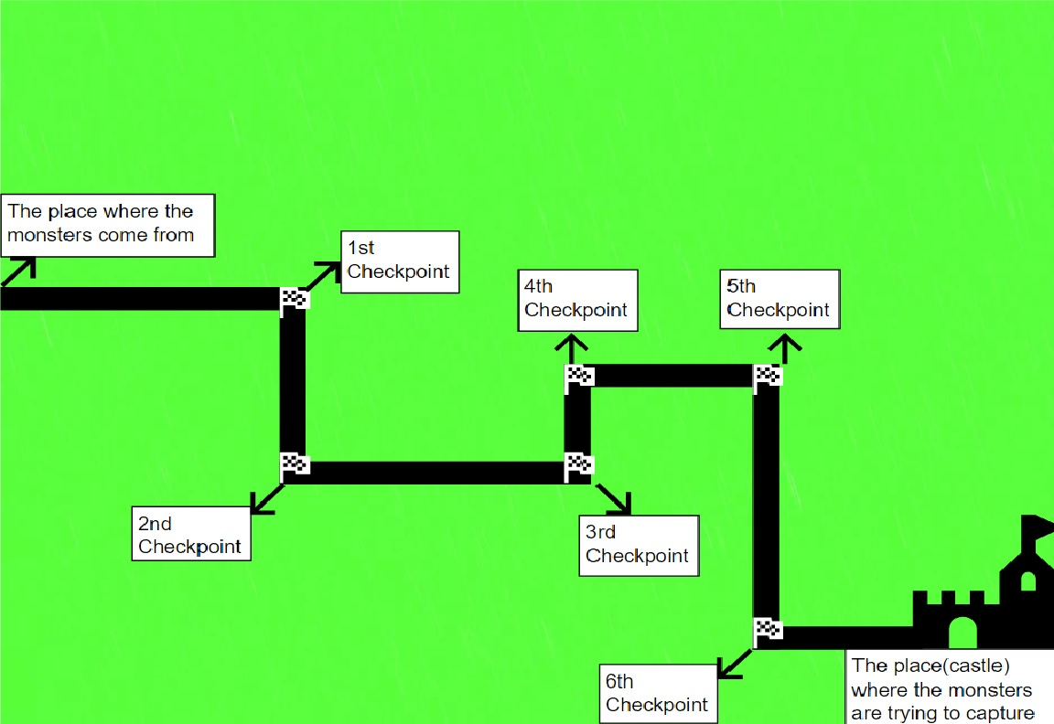

## Using References

<http://armorgames.com/play/15079/defendless>

Don’t forget to acknowledge any sources that you make use of. Claiming other people's work & ideas as your own is considered cheating and carries severe penalties. Make it very clear what is your work and what help, words, ideas, etc., you have taken from elsewhere. Be sure to put quotation marks around any sections of text you copy from elsewhere and add a reference to the original source (see [[1]] for general information and [[2]] and [[3]] for examples of information required for book, journal and web-based sources).

You can insert references in the text by selecting “Insert|Reference-Footnotes… Endnotes.” This template uses sequential numbers for references, the most common format used for technical articles. The template includes a macro, "Create_Reference" which should insert a link into the text and a corresponding entry into the References section at the end of the document, which you can then edit. You can invoke the macro by pressing Control-R (but you may need to "Tools|Unprotect Document" and/or Enable-Macros first!) Note: newer versions of Word may now include this reference style—check the help.

## And Outlines?

Once you understand the basics, you may want to switch to "Outline" view to sort out your ideas before returning to the "Page Layout" view to write the actual content. If you learn to use styles, outlines and endnotes properly, then Word sorts out the numbering, formatting, etc. for you. Try inserting and deleting some of the references from the text and notice again how the other numbers change automatically. Having the machine do the layout and such numbering automatically, enables you to concentrate on what is really important, the content. Neat and very professional looking, eh?

# Summary & Conclusions

And finally… don’t forget that Word can help to check your spelling (and grammar!)

Maintaining lists of research references that can be reused when writing journal articles can be a real pain, especially when citation styles vary so much from journal to journal. When you have time I suggest you look at reference managers (e.g. JabRef for BibTeX, or websites such as CiteSeer), as well as other document creation options (e.g. LyX, LateX and OpenOffice.)

Good Luck.

1. The Short Guide to Avoiding Plagiarism, David Davenport & Derya Davenport. URL: http://www.cs.bilkent.edu.tr/~david/plagiarism/ 2008. Last visited: 31/01/2017.
2. Reference books and journals by providing sufficient information about the source so that someone can easily find it. Include: title, author, journal, publisher & publication date (page no’s too, if applicable.)
3. Reference web-based resources by giving their title, author, URL and date (posted & visited.)